Healing With Aurora Client Intake Form

Name________________________________________________

Primary reason for visit_________________________________
_____________________________________________________
_____________________________________________________

Physical Symptoms: (circle areas of concern)

Front Back
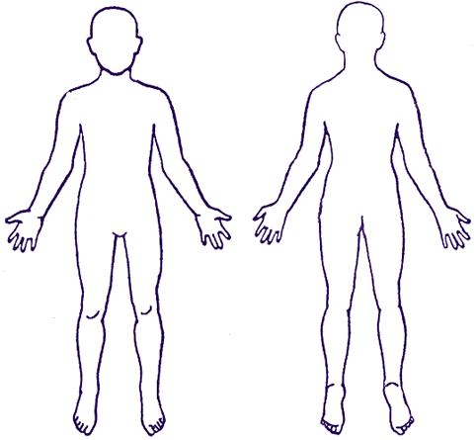

CHAKRA HEALTH (Circle all that apply)

CROWN 👑

Loneliness, lack of connection or guidance from a higher power, migraines, scared of change, lack of direction

THIRD EYE 👁️

Lack of focus, clouded judgement, headaches, overthinker, low intuition, vision problems

THROAT

Fear judgement, fear speaking out, frustration because you don’t feel like people hear what you say, speak fast, thyroid issues

HEART 💚

Fear of commitment, feeling you have to please others in order to be loved,
Guarded due to past hurts, trouble with giving/receiving, hold grudges, physical heart issues such as heart disease, heart attack

SOLAR PLEXUS ☀️

Low self-esteem, poor decision-making, feeling powerless/victim, feel as if people take advantage, seek approval from others, digestion issues, stomach pain

SACRAL CHAKRA

Low sex drive, lack of creativity, emotional confusion, reproductive disorders,
Repetitive dysfunctional relationships

ROOT CHAKRA
Depression, anxiety, persistent financial problems, feeling stuck, arthritis, lower back pain
(circle all that apply)
Are you comfortable with the use of
sage, palo santos, essential oils, crystals, reiki touch? Yes or no

Are you known to be sensitive to light or have seizures? Yes or no

Disclaimer: Crystal healing and other types of energy work are not to be considered as a substitute for conventional medicine. If you have a serious health issue, you should consult your doctor and make complementary healing part of a complete health care program.
I ____________ take full responsibility for my health and do not hold Aurora accountable.

signature___________________________________

date________________________________________

